The Sound of Safety
Make a Safe Exit!

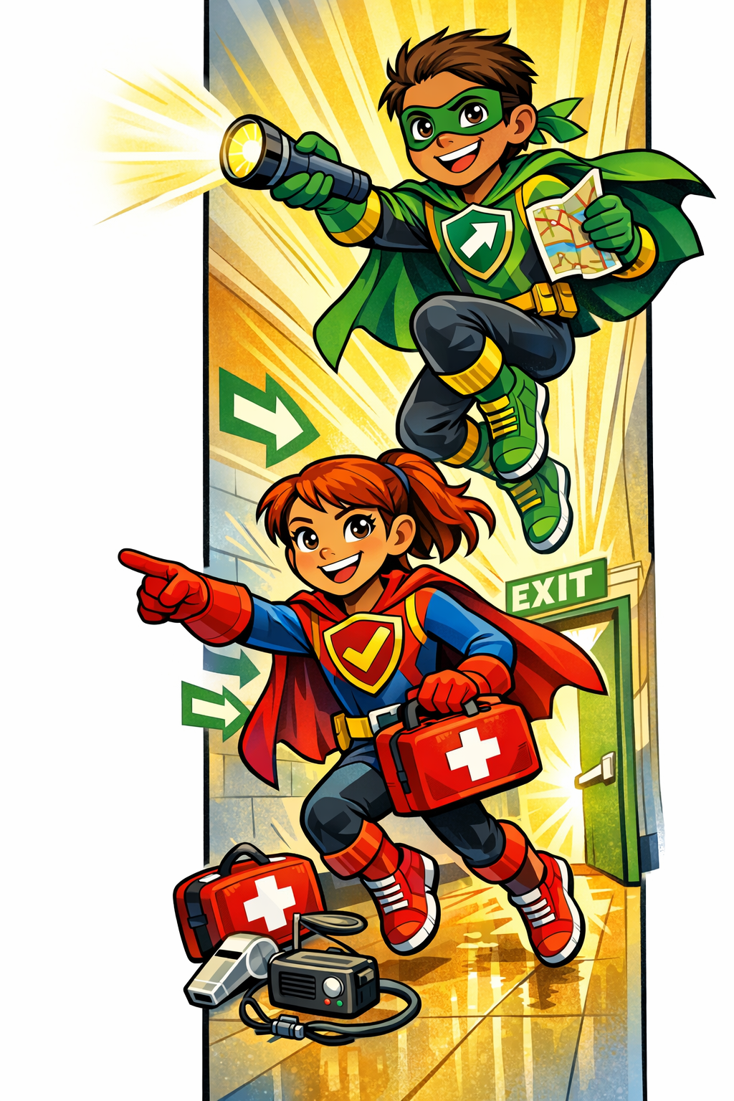
Kids Can Help Their Family Escape in an Emergency

Hey Kids — Be a Safety Hero!
In a fire or emergency, getting out quickly and safely is very important. You can help your family be prepared!

Safe Exit Tips
Talk to your parents about these safety checks:

Keep Escape Paths Clear
- Keep hallways, stairs, doors, and windows free of toys, shoes, and clutter.
- Never block exits or emergency windows.

Know How to Get Out
- Learn two ways out of each room if possible.
- Make sure everyone knows how to unlock and open doors and windows.
- Check that window security bars can open from the inside.

Make a Family Escape Plan
Ask your family:
- Do we have a fire escape plan?
- Where is our outside meeting place?
- Have we practiced our plan recently?

Practice Staying Safe
- Practice family fire drills day and night.
- Crawl low under smoke.
- Once outside, stay outside and call 911.

Remember:
Clear Paths Save Lives!

Be a Safety Hero and help your family practice their escape plan today!

